WCMGA Chapter Meeting
January 8, 2019

8:02 pm Meeting Called to Order by Susan Albright
Shirley Wolcott - MGs of Note – See Chapter Chat for Details. Need help with Hospitality Committee at Trainings and Chapter Meetings. Please let Shirley know if you are interested in helping.
Jean Natter/Susan Albright - Remembering fellow chapter member, Bill Greer - WCMGA Member since 1993, Bill Greer passed away on January 1, 2019. Bill was a long-standing volunteer at the phones, a greeter at registration table for new MG Trainings, a leader for phone orientation sessions with interns and in the true sense of the word, a mentor to many WCMGA members. He will be missed.
Bill Greer’s memorial service is scheduled for Saturday, January 26th at 2:00 pm. It will be held at Valley Community Presbyterian Church, 8060 SW Brentwood Street, Portland, Oregon 97225, 503-292-3537. The church is located on the corner of Laurelwood Road and Brentwood, not too far from the Raleigh Hills Fred Meyers on Beaverton-Hillsdale Road. It will be a fairly traditional service with a short message, a hymn or two, some readings, and a chance for people to speak about Bill if those so choose. There will be a reception afterwards upstairs in the gym.
Marilyn Berti - WCMGA Strategic Plan 2019-2021 – Strategic Plan done every 3 years. We are focusing on 5 priorities. See attachment for details and committee leads. See attachment #1
Susan Albright - Budget Highlights from Marilynn Turner – Reviewed balance, revenue and expenses and additional expense from water usage at Jenkins Learning Estate. See attachment #2 narrative and #3 Year End Budget.
Pat Simmons - Plant Sale – April 27th at PCC – Please check your January 6th email for details or contact Pat at pbsimmons@comcast.net 989.859.3115 if you are interested in helping out. Many tasks large and small!
Marti Farris - Reporting 2018 Intel volunteer hours – please submit by January 15th. Hours to be reported are thru the end of December 2018.
Louise Gomez-Burgess - New MG Trainings location – Hillsboro. Looking for AM person to help with hospitality. Call or email if questions. See January 2019 MMG Newsletter for training class schedule.

Meeting Adjourned 8:45 pm.
Respectfully Submitted by Lisa Gillespie, WCMGA Recording Secretary January 9, 2019
Approved by:
ATTACHMENT #1
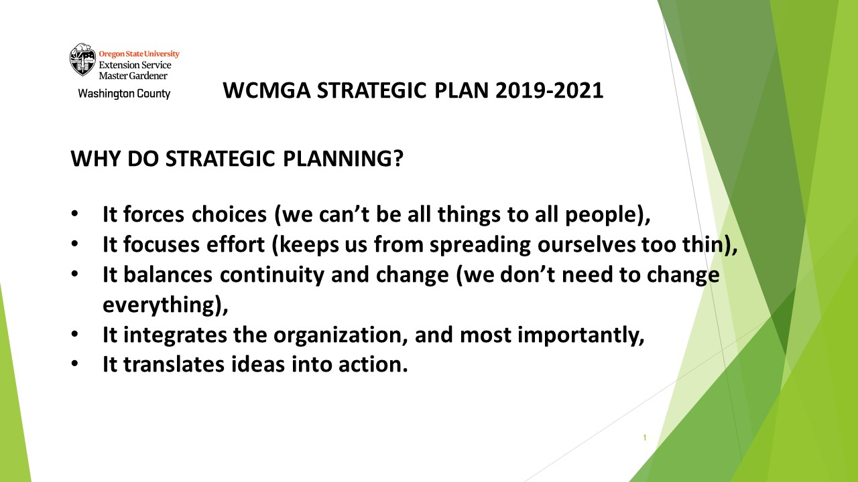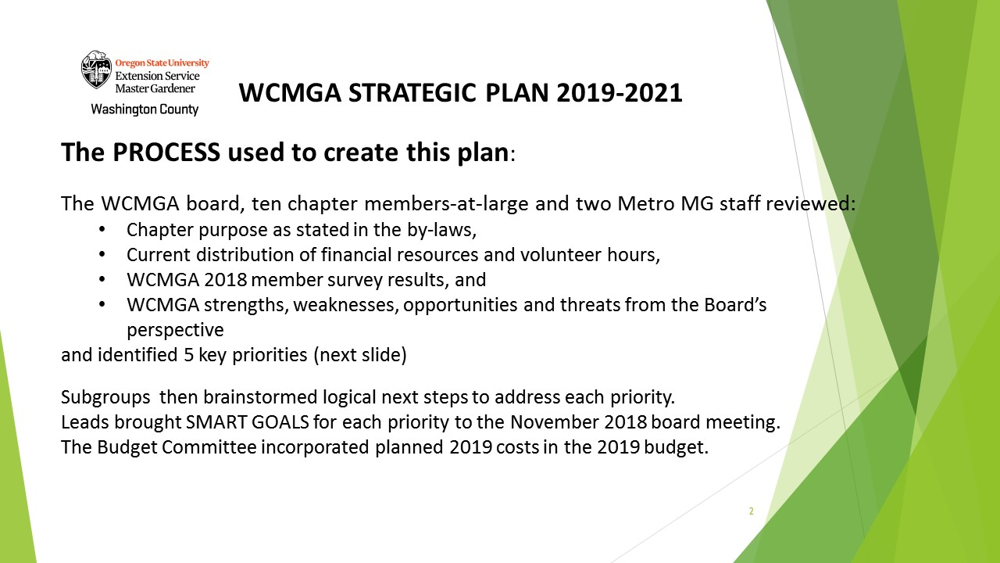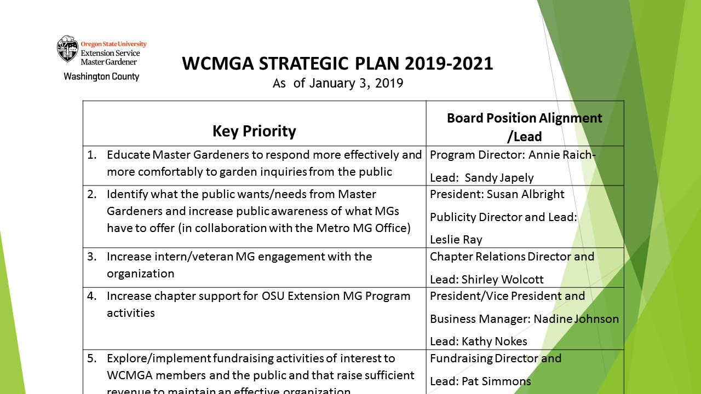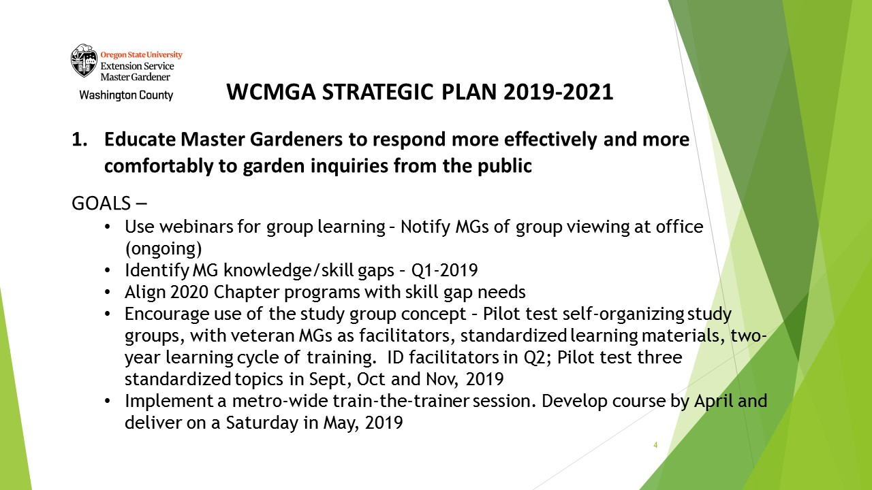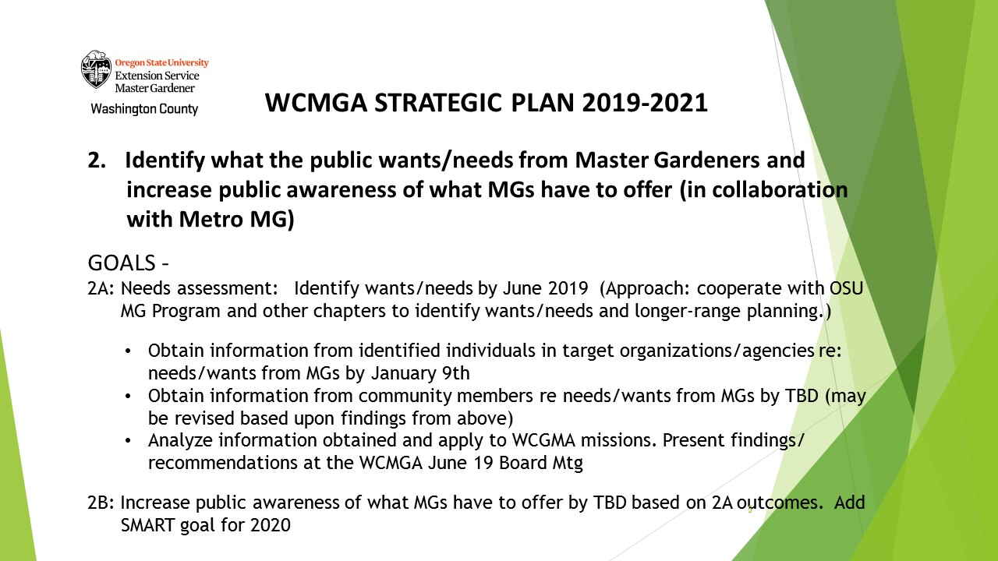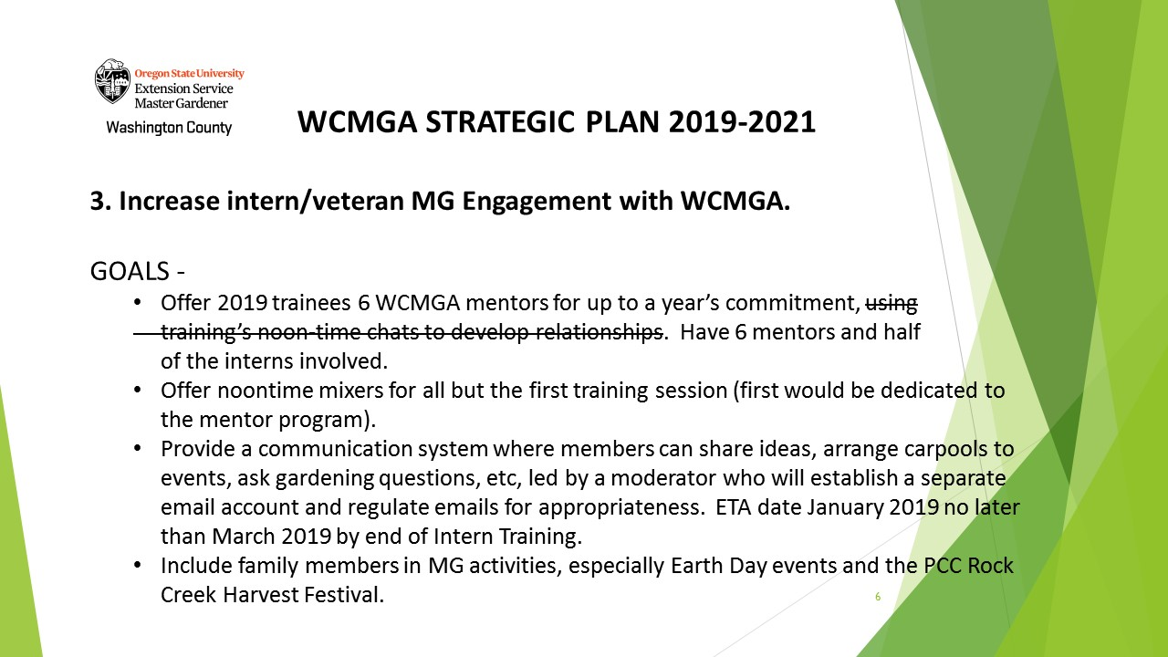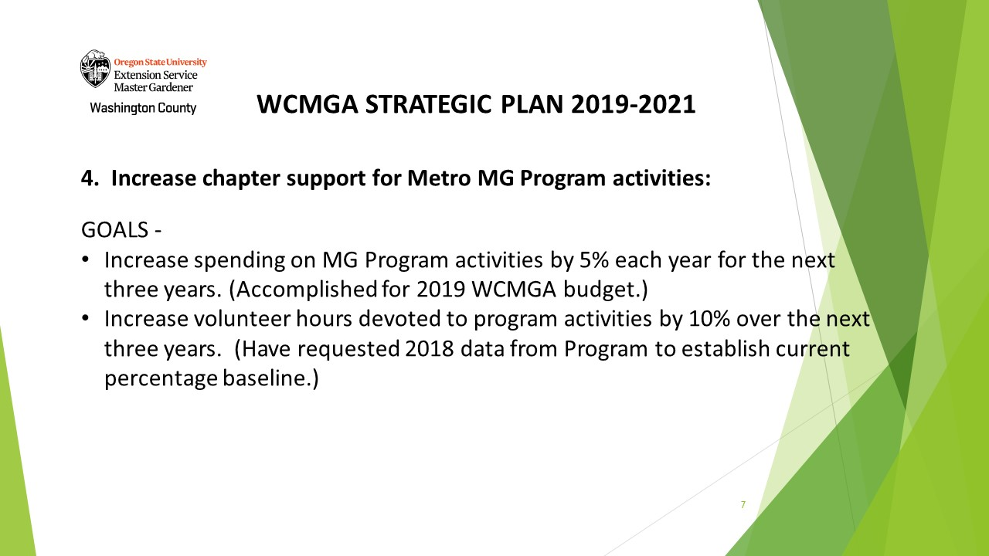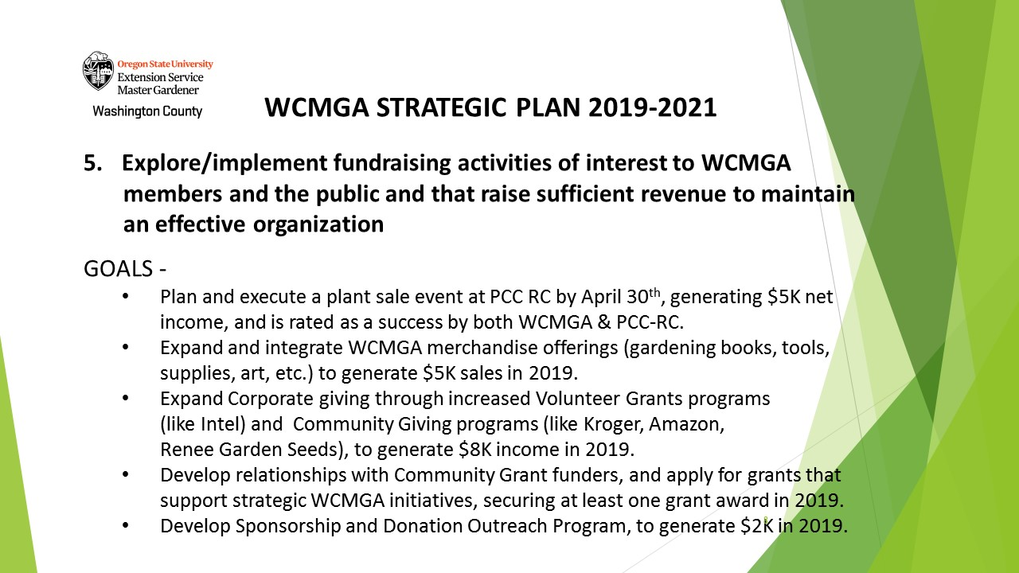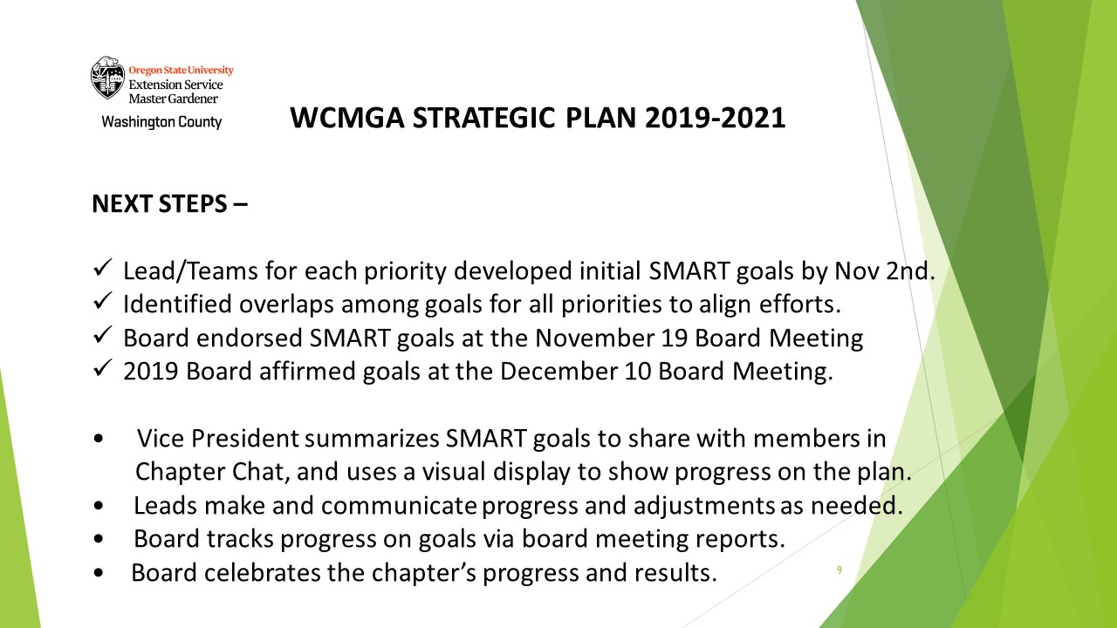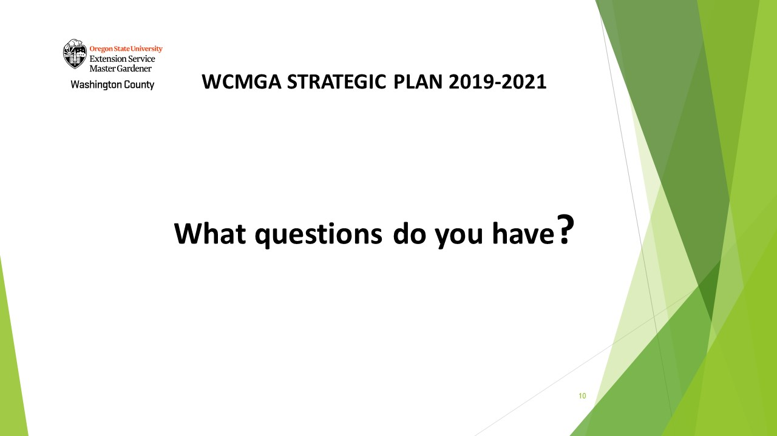

ATTACHMENT # 2
Treasurer’s Report January 2019
(presented at 1/8/2018 WCMGA Chapter Meeting)
The treasurer (Marilynn Turner) is away tonight. She asked me (Susan Albright) to make a budget report for December on her behalf.
The chapter ended 2018 with a cash balance of $42,344, about $1,800 less than the balances going into the year. That’s over $25,000 more than we planned for in 2018. We are in a good financial position going into 2019.
December was a busy month with almost $4,000 in expenses and a little over half that in income. One of the expenses was an unexpectedly high water bill from Tualatin Hills Park and Recreation District that exceeded the amount budgeted by $500. The Board unanimously authorized the budget overage by an email vote in December. As required by our Standing Rules, I’m reporting that budget overage to the membership tonight and the results of the Board motion will be in the minutes on the webpage.
A couple of highlights for the year: Overall, expenditures were well within the budgeted amounts. Congratulations to all those who kept a close eye on chapter finances. Expenses were $11,000 under budget for 2018.
Chapter’s income was $14,000 greater than planned. At year end, we had $3,200 in annual dues and an additional $3,200 in individual donations. Thank you to everyone who paid dues and donated.
The chapter earned over $31,000 through fundraising efforts – plant sale, sales of books and loupes and targeted fundraising for the Education Garden at PCC Rock Creek. The team efforts made a very big impact this year – $10,000 more than planned. Thanks to everyone who had a part in making 2018 a very successful fundraising year.
Intel volunteers again made a major contribution this past year. Their volunteer hours earned just under $6,700 for the chapter. Thank you, Intel volunteers.
The December budget report will be posted on the WCMGA website soon.

ATTACHMENT #3
WCMGA 2018 Budget
December Report - Net Worth
12/31/18
Beginning Net Worth | 44,119.11
Income - Unrestricted | 1,348.91
Income - Restricted | 734.21
Expenses - Unrestricted Expenses - Restricted | (3,858.29)
Net income (Loss)
(1,775.17)
42,343.94
Ending Net WorthNote 1
Checking Account 10,391.83
Savings 15,482.11
Reserve
16,470.00
42,343.94
Note 1: This month's balance includes the following
restricted funds: 646.64

