FRED MEYERS REWARDS
Do you shop at Fred Meyers? Do you have a Fred Meyer Rewards Card? Fred Meyer has a Community Rewards program that donates to local nonprofits such as WCMGA based on purchases made by Rewards Cards linked to the nonprofit. If you don’t have a Rewards Card, stop by the Customer Service Desk and sign up for one. It’s easy to link your Rewards Card, even if you have lost your card and use a phone number for your rewards. There is no cost to you and you will still get your Rewards Points, Fuel Points, and Rebates. We hope to receive $150.00 this year from Community Rewards.
Go to Fred Meyer Community Rewards to either create an online account tied to your rewards card or sign in to your existing online Fred Meyer Account.
If you are creating a new on-line account. Enter your zip code in the “Your Location” space, click the Find button and select your nearest Fred Meyer store.
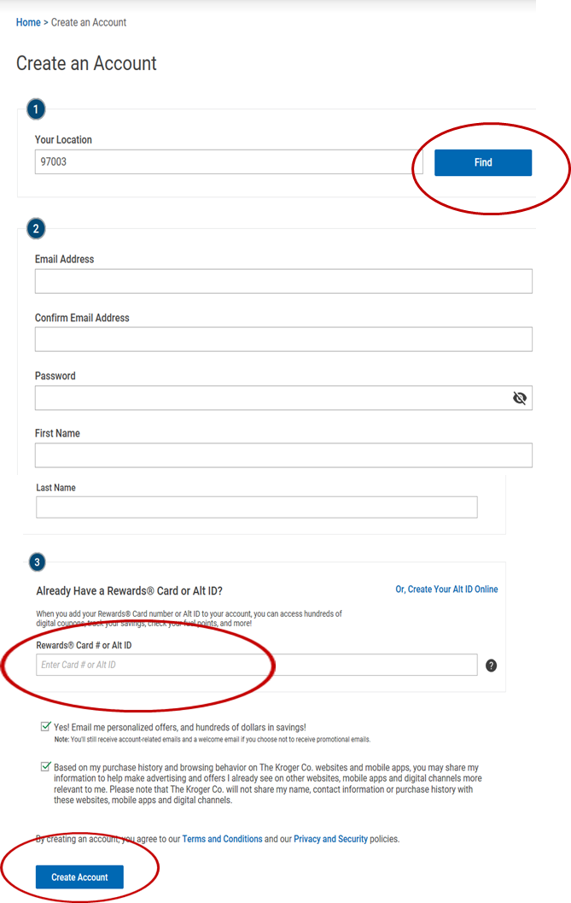
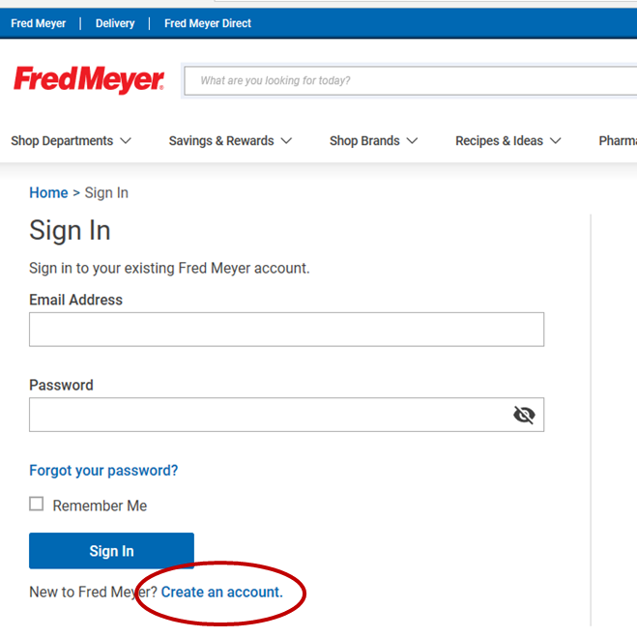
Fill in the information requested in Step 2. In Step 3, enter Rewards Card # or the phone number you use in place of your Reward Card. Then select Create Account at the bottom of the page.

Once you are logged in, get to the Community Rewards Page by clicking the drop down "Save" located at the top of the screen. Click on the "Fred Meyer Community Rewards" at the bottom of the drop down.
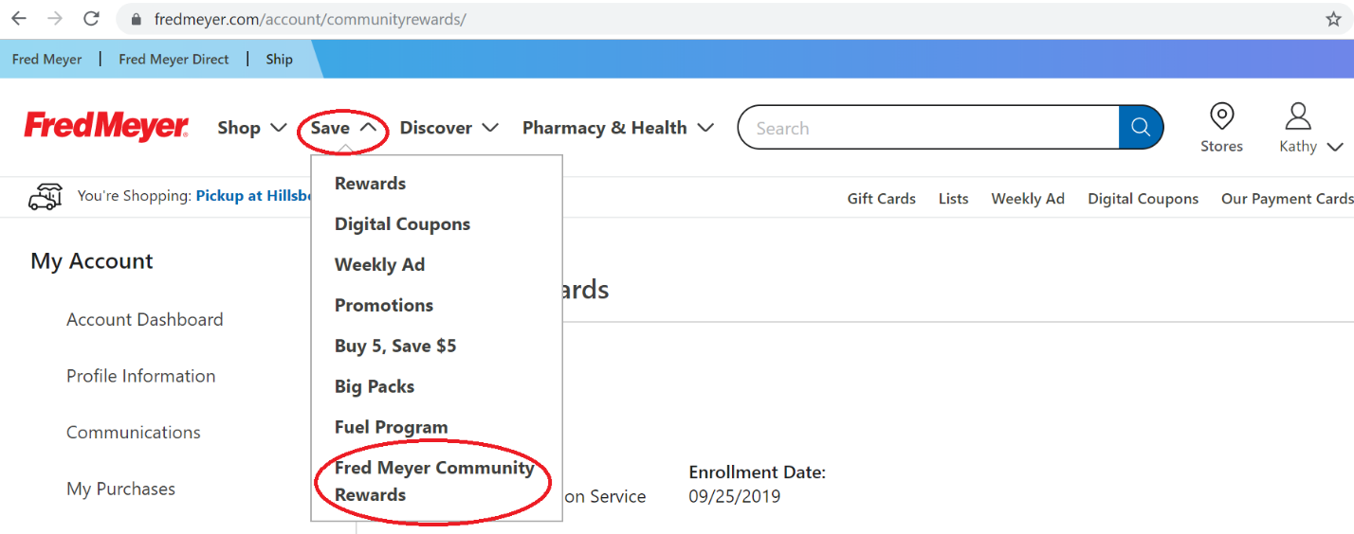

Mid Screen Select the hyperlink " Link your rewards card now"
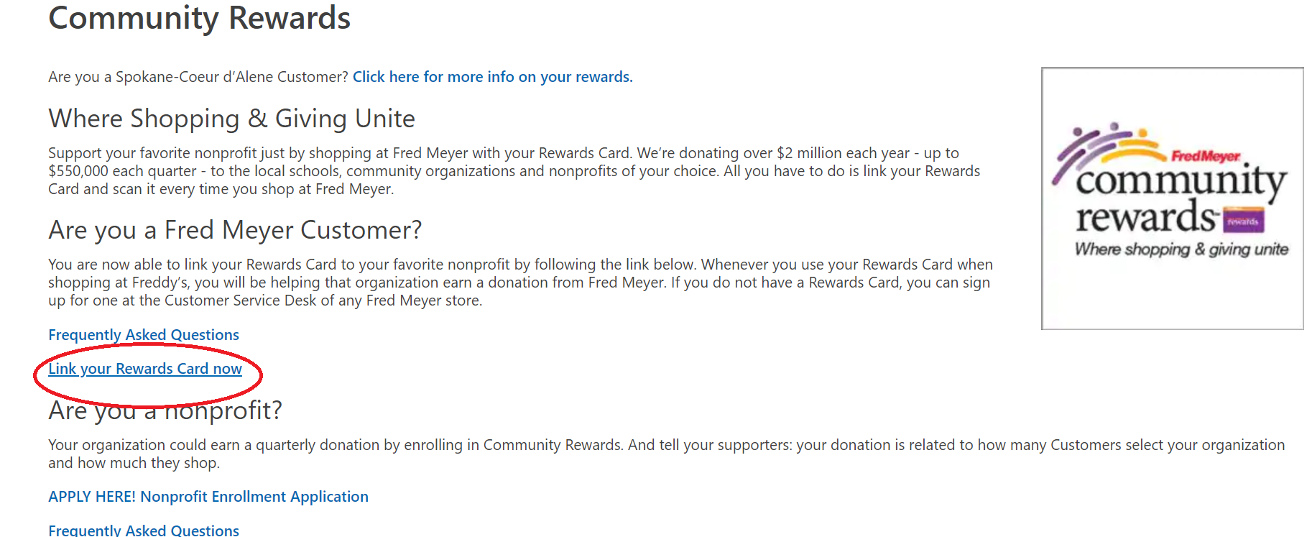

On the Community Rewards page, enter WCMGA and select Search. The Search Results will appear below. Select Enroll.

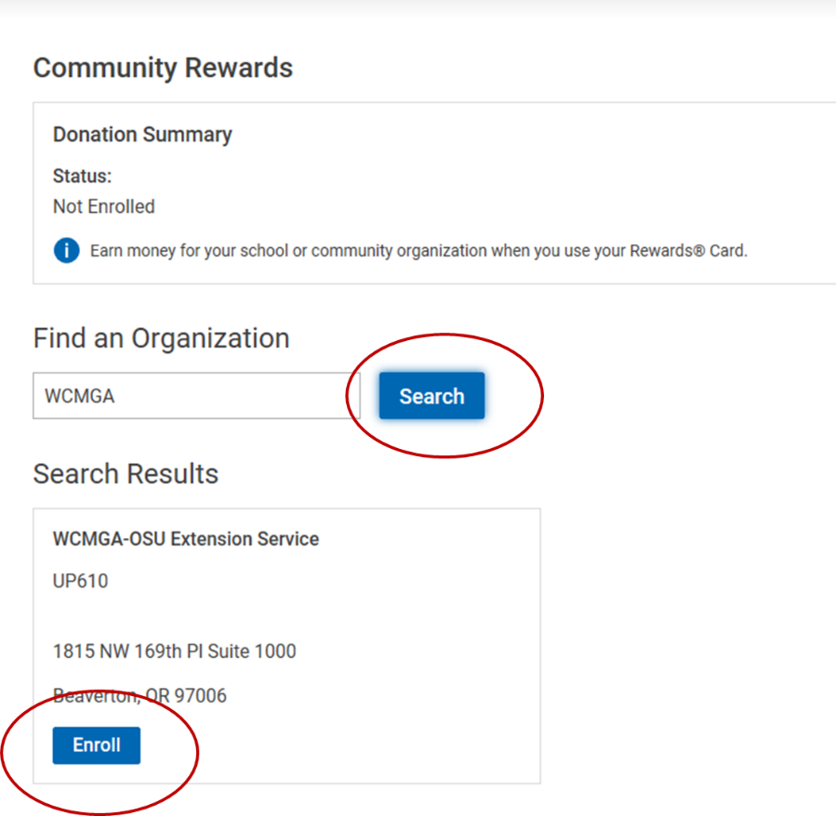
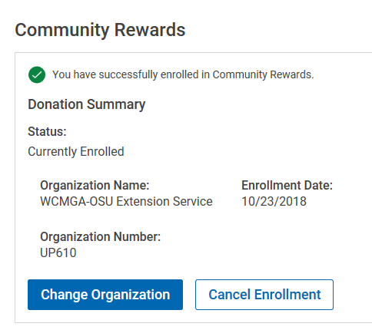
Donation Summary shows the enrollment was successful.

