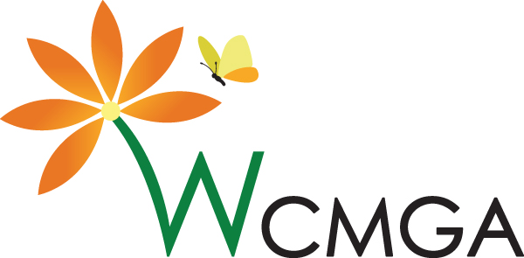
Gardening with PNW Native Plants Resource List
Compiled by OSU Extension Washington Co Master Gardener Volunteer: Robin Carpenter
For 'Gardening with Pacific Northwest NativePlants', January 23 2026, at PCC RC. In the Garden

Resources: books & publications

Gardening with Native Plants of the Pacific Northwest Arthur R. Kruckeberg & Linda Chalker-Scott, University of Washington Press, Third Edition, March 2019.

Landscaping for Wildlife in the Pacific Northwest Russell Link, University of Washington Press, Oct 25, 1999

Oregon State University:
- Gardenecology.oregonstate.edu
- Gardening with Oregon Native Plants West of the Cascades L. McMahan, H. Stoven, & E. Szonntag,
OSU Extension EC 1577, revised October 2022.
- Selecting Native Plant Materials for Restoration Projects B. Withrow-Robinson & R. Johnson,
OSU Extension EM 8885-E, November 2006.
- Living On the Land: Got a Stream? Grow Plants! E. Hammond, B. Tuck, S. Kerr & S. Olson,
OSU Extension EC 1645, October 2014, Reviewed 2018.

Plants of the Pacific Northwest Coast J. Pojar & A. MacKinnon, Lone Pine Press, August 1, 2016.

Encyclopedia of Native Plants for Pacific Northwest Landscapes

Real Gardens Grow Natives E.M. Stark, Skipstone Publishing, Sept 2014. (book)
(blog) https://realgardensgrownatives.com

Bringing Nature Home D. Tallamy, Timber Press/Hachette Book Group

The Meadowscaping Handbook West Multnomah Soil and Water Conservation District publication

The Pacific Northwest Native Plant Primer K. Currin & A. Merritt, Timber Press, Feb 2023

Resources: expertise

Backyard Habitat Certification Program (Bird Alliance of Oregon)
Metro Master Gardeners
Native Plant Society of Oregon
Native Seed Network
Soil and Water Conservation Districts: Tualatin SWCD, East Multnomah SWCD, West Multnomah SWCD
On Facebook:
Friends of Backyard Habitat Greater Portland Oregon Area
Native Plants in Oregon Discussion
Westside Habitat Group – an in-person derivative of the Facebook group with an active WhatsApp group (to join the WhatsApp group, go to the Other Resources tab)

Resources: downloadables

Clean Water Services
Native Plants – including the Gardening With Native Plants poster
The Meadowscaping Handbook
Portland Plant List
Xerces Society

Resources: online
Clean Water Services Clean Water Services (CWS) district includes unincorporated Washington County. Contact CWS to see if they are doing their free native plant giveaway in 2026.
Native Plant and Seed Sources - a comprehensive list of sources for native plant and seed in the greater Portland area.
Hansen's Native Plant Database
National Wildlife Federation
OregonFlora
OSU woody plants database
PlantNative
Portland.gov/bes
The Garden Professors (blog)

Additional Training
Soil School
Ten Minute University

